**Week- 4 Assignment**

**Problem definition:**

Since the evolution started mankind wants to have a better living standards, as their needs are increasing in day-to-day life, people are expected to fulfil them in one way or another. As we see everyday transportation became very big issue to reach from one place to another. Modernisation dragging the people to all major cities for better work opportunity and life style, cities like those are facing traffic and parking issues. To resolve these issues, need to develop infrastructure better than yesterday. Other than the traffic issue, we are going to focus on parking problem in all the densely crowded places inside Toronto city.

The specific reason behind taking Toronto city under consideration is that we have a client, who wants to have a new parking lot for public and to generate an income of source from it. But, he is not sure about his location in Toronto where to build it. He has set of preferences for an ideal location. It has to be near to busiest neighbourhood (but away from the other public parking lots or where there are less parking lots available than the need), where there is a parking problem. In such a way he can make some income out of this project.

Parking space features: These are the features our client wants have in his parking lot. So, using these features will help to know exactly where he can have one.

Normal- more than 200

Handicap- 10 to 15

By using top ten neighbourhoods which are usually busy in Toronto, we have to find out the public parking lots and then figure it out, under which neighbourhood they comes. After that we can suggest our client which neighbourhood is suitable for his project.

**Data Description**:

In order to initialise the first step, we need the data about existing parking lots in Toronto city. This data we are importing from ckan opensource website [(parking_lots_info_2016)](https://ckan0.cf.opendata.inter.prod-toronto.ca/it/dataset/parking-lot-facilities/resource/09ec2066-4a25-4fa2-a67b-1732c69b4a5e), this data downloaded to internal pc memory in xlsx format.

The data is not the current information, these statistics were recorded in the year 2016.

This imported file has a data about parking lot name, available places, GIS coordinates of the location where they are located in Toronto, type of the parking lot (private/ public). By the help of geocoder framework in python we can extract the neighbourhoods of parking lots, where they were located by using those GIS coordinates.

Geocoder:

In python we have a special package called Geocoder, which is used to get the geospatial latitudes and longitudes of any city, place or a venue by giving it’s name following the country or state name to it and vice versa.

Image 1: Geocoder package- reverse method

As we see in the above image, geocoder package reverse method was used to get the location address, result of this method will be like a string of elements including name of the location, road, area, neighbourhood and city, separated by commas in between each object. In order to extract only the neighbourhood of parking lots split operation was implemented. Since it produces the list of address objects, where the 3rd places supposed to be the name of neighbourhood, we called the object with 2 in square brackets. Then all the neighbourhoods of parking lots are appended to the Neighbourhood list.

Foursquare:

Foursquare is an independent public platform, where it provides the location based information depending on API requests from different other interactive platforms. By using my on credentials of Foursquare I made some API requests to get the information on above acquired neighbourhoods in Toronto city. The whole reason is of involving Foursquare is to get aware of those neighbourhoods and how many venues are located in those.

Folium:

As soon as we get the data of venues of neighbourhoods, we plot them on a Toronto city map using folium package on python. It creates more interaction for a stakeholder with the data. Going further I have even added all the parking lots in those neighbourhoods in different colours (under 100 available places & others in different colours), this adds more information to the map.

Image 2: Toronto map generated using Folium.

**Methodology:**

Methodology is basic ideology of data analysis project. This approach of filtering suitable locations for our client’s “Parking lot” has explained step by step in the below following:

1. Importing a CSV file to Pandas Data Frame “data” dropping all the NaN rows and ‘Parking lot Asset ID’ from the data frame, it consist of these column features: “Park Name”, “Parking Spaces”, “Handicap Parking Spaces”, “GIS Coordinate”, “Access”. Access indicates the status of the Parking lot which will be either “Public/ Private”. As per the client interest we are choosing to go with “Public”.
2. Since we have “GIS Coordinate” for all the parking lots, we are going to slice them into “Latitude” & “Longitude” new columns (simultaneously dropping GIS Coordinate column).

Image 3: Data frame “data”

1. Using ‘geolocator’ API, we recover ‘Neighbourhood’ names of parking lots and add them to current data frame under a column name “Neighbourhood”.
2. Then we create a map representation using folium, gives a clear idea about locations of parking lots.
3. Next step will be figure out the popularity of the Neighbourhoods and surrounding number of venues.
4. We are going to use “FOURSQUARE” API to get up to 50 venues in the radius of 150 MT surroundings of those Parking lots.
5. All the recovered venues are saved under a data frame “Venues” (shape of the data frame is 453 rows x 7 columns) and in this we have unique Neighbourhoods of 123 and 372 different venues.



Image 4: Data frame “Venues”

1. Since we have all the “Venues” & “Parking lots” we are going to mark them up on a Toronto city map with different colours(see Image 2).
2. Next step would be approaching with K mean clustering for classifying them as per the data we gathered. For this analysis we use the data frame “Neighbourhood_vc”.

Image 4: Data Frame “Neighbourhood_vc”

1. Before we go for K mean classification, we would like to see the variation between “no of venues” and “no of parking lots”.

Image 5: Scatter plot for ‘no of venues’ vs ‘no of parking lots’

K-Mean :

I believe it is necessary to classify this unlabelled data into groups based on number of venues, number of parking plots and their places available in neighbourhoods. There might be better solution out there to provide much insight through these analysis to our client. But, for this moment I planned to proceed with K-mean clustering.

Before we go further we should know how many clusters in our K mean clustering would really make up to our classification i.e. how many clusters we need?

In order to answer that question we consider “Elbow method” to figure out the exact number we need to mention in K-mean clustering. We are running elbow method to find suitable cluster size by running K-means from 2 to 9. In the below figure there is plot graph between “K-means.inertia” VS “n_clusters”.

Image 6: Line plot for ‘K-means.inertia’ vs ‘n_clusters’

After thorough observation there is we have to consider that the elbow method suggests us to go with a cluster size of 4, but there are better results by using 5 as n_clusters in K-mean. Finally we are going with 5 clusters. In the below table all the neighbourhoods respective to their clusters are mentioned.

|  |  |  |
| --- | --- | --- |
| **Cluster** | **Description** | **Size of the Cluster** |
| 4 | maximum number of Parking lots and Venues | 29 |
| 3 | | | 3 |
| 2 | | | 29 |
| 1 |  | 3 |
| 0 | minimum number of Parking lots and Venues | 59 |

Table 1: Cluster description

Discussion on K-means cluster classification:

As we have 5 clusters from K mean, each one describes the levels of 'no of venues' and 'no of parking lots' in that neighbourhood available at the that time of data we are using for this data analysis(2016). As we see the results of 'cluster 2', it has three neighbourhoods with different proportions between venues and parking lots. So, it is clear by now this classification is not yet clear to make a valid decision for our client. To go further we need to see deeply into each cluster and know the proportions of venues and parking lots distribution among them.

Further analysis it is time to make different data frames for each cluster and, observe them more closely by plotting the venues and parking lots information.

Cluster 0:

(Features scales between 1 to 2)

As it is shown in the above scatter graph between "Venues vs Parking lots" in 59 Neighbourhoods (who were clustered under Cl_0). There are very slightest differences between both venues and parking lots for these 59 neighbourhoods. It disqualifies, as we are looking for the disproportion or very huge change between both features.

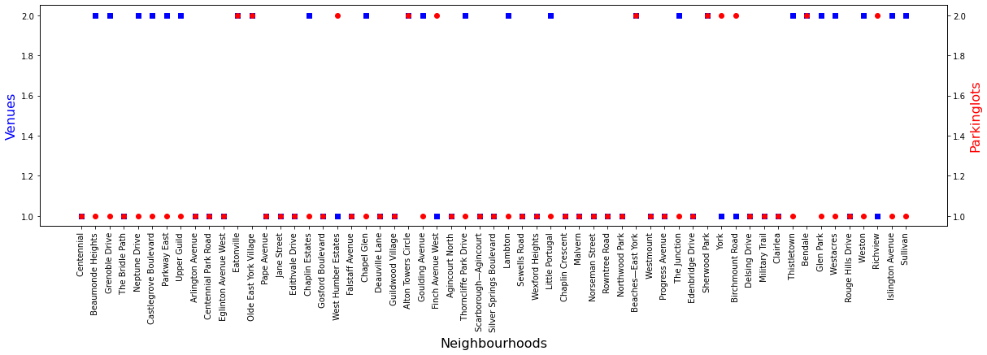

Image 6: Cluster 0

Cluster 1:

(Features scaling between 8 to 11 for Venues and 8 to 12 for Parking lots)

This cluster has not more interesting than the last one. May be consider taking `York Centre` for the final Neighbourhood short list. It has 11 venues with 8 parking lots. We have to see the other clusters for more information at this point.

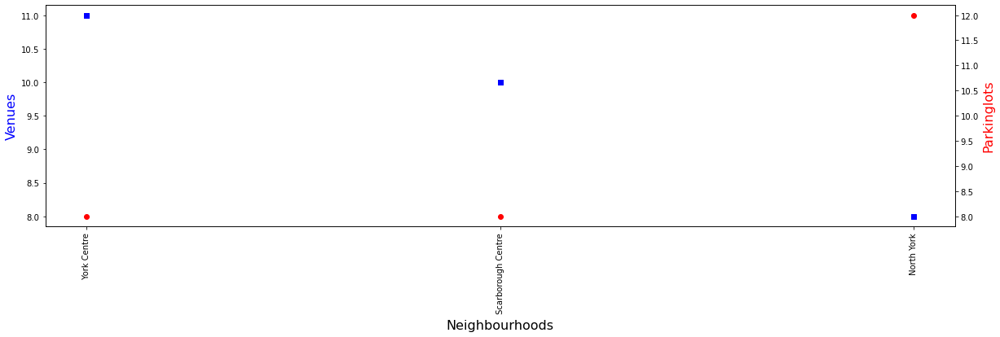

Image 7: Cluster 1

Cluster 2:

(Features scaling between 2 to 4 for Venues and 1 to 7 for Parking lots)

As we see above this cluster of neighbourhoods, there are some of them has disproportion in both features. We can take them into consideration for final short list of Neighbourhoods(7). Below table you can see them:

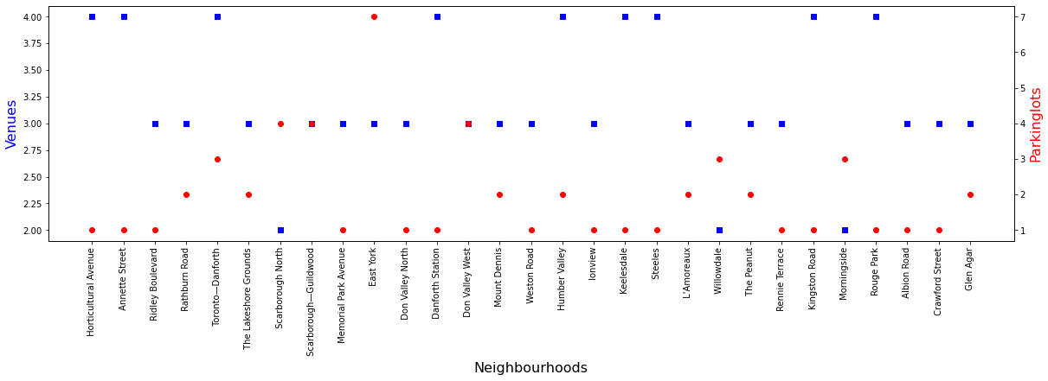

Image 8: Cluster 2

Cluster 3:

(Features scaling between 16 to 26 for Venues and 9 to 10 for Parking lots)

All this Neighbourhoods qualifies the requirement to be in final shortlist.

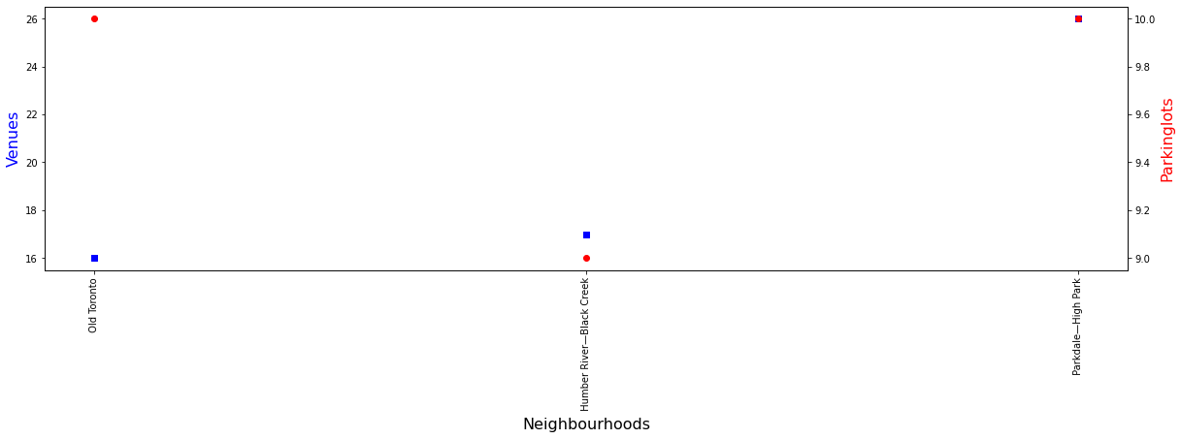

Image 9: Cluster 3

Cluster 4*:*

(Features are scaling between for Venues 2 to 7 and Parking lots 1 to 7)

Apart from all the neighbourhoods in this category `The beaches` shows variance of one Parking lot for 7 Venues. This will the perfect place to advise our client basing the complete analysis.

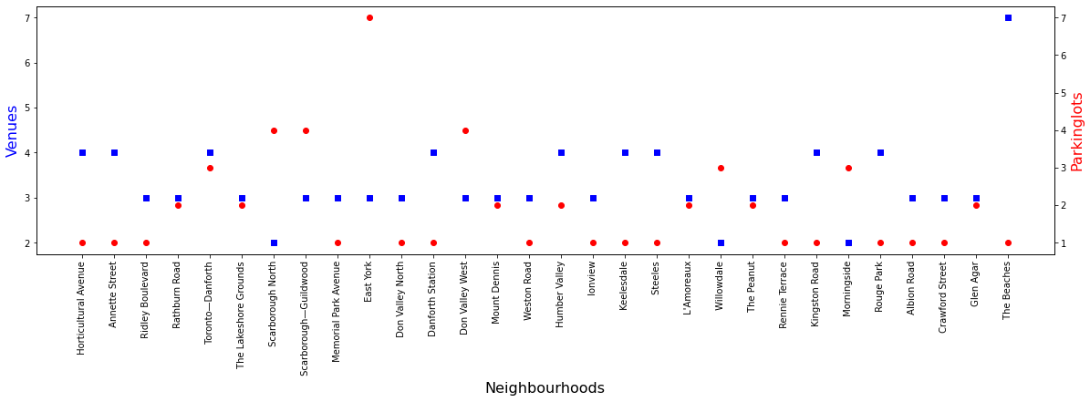

Image 10: Cluster 4

**Results:**

There are 11 short listed Neighborhoods, which we think they have requirement for a new Parking lot. All these are short listed form the above clusters and they have been saved under a data frame “dff”. Out of these 11 Neighborhoods 2 have a special proportion which are marked in red in below map they are ‘Old Toronto’, ‘Humber river- Black creek’ and ‘Parkdale- High park’.

Image 11: Data frame “dff”(Shortlisted Neighbourhoods)

Image 12: Map of Toronto with short listed Neighbourhoods marking

|  |  |
| --- | --- |
| **Colour** | Representation |
| Blue | Neighbourhoods with Parking lots less than 9 |
| Red | Neighbourhoods with Parking lots 9 or mor |

Table 2: Colour representation in Image 12.

In the above Map of Toronto city, there are two neighbourhoods marked in red among 11. One is 'Parkdale- High park' which has 26 venues and 10 parking lots, on the other hand 'Old Toronto' which has 16 venues and 10 parking lots. After observing these two places they have gap between numbers of venues and parking lots. In my opinion they are most feasible neighbourhoods at this point and they are located in the centre on the city, where we get most of the crowd.

**Discussion:**

As we went through all the available data and analysis to filter the most suitable neighbourhood for a new parking lot facility establishment there are some specifics to point out. The CSV file we used for this capstone project has no current data, information was gathered in year 2016(we can't really on this final results if we want to use it for today’s scenario) and we only used the parking lots which are available for public access. Going further we have successfully shortlisted 11 possible neighbourhoods to have a new parking lot finally. But, these are only the statistics we have it on the table for now. Next step would be analysing the available spaces and local authorities approval.

**Conclusion:**

As it has been tough to short list the suitable location for client in Toronto city. Ended up having 11 locations for constructing a new parking lot. But, in my conclusion the results would have been more realistic, if we would have more or/and present data to use. There might be a better approach for this whole process, but it is the one I choose to get final output.